# Online diary: 23/10/20

# Strategic and twitch skill

# 1.0 Introduction

The premise of the assignment was to create a game that allowed social media to be a core part of the playing process, using points, rewards and penalty systems to enhance the experience of the game. This game sought to bring the new the technological age into and old-fashioned game called charades.

# Material

Recreating this game is very simple, requiring only a timer of some form, a random name generator found online and a notepad to keep score.

# Rules

The rules of the game are started by the first player taking a spin of the wheel to decide which category they are going to be playing. From the player then spins a subsequent wheel to decide what subject from that category they are going to be using (see figures 1.1 and 1.2 below).

A is one of the possible outcomes that is available to you within one of the categories.

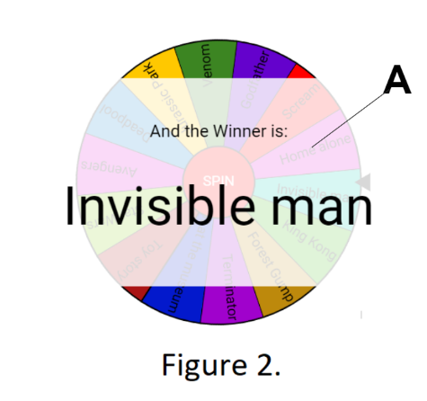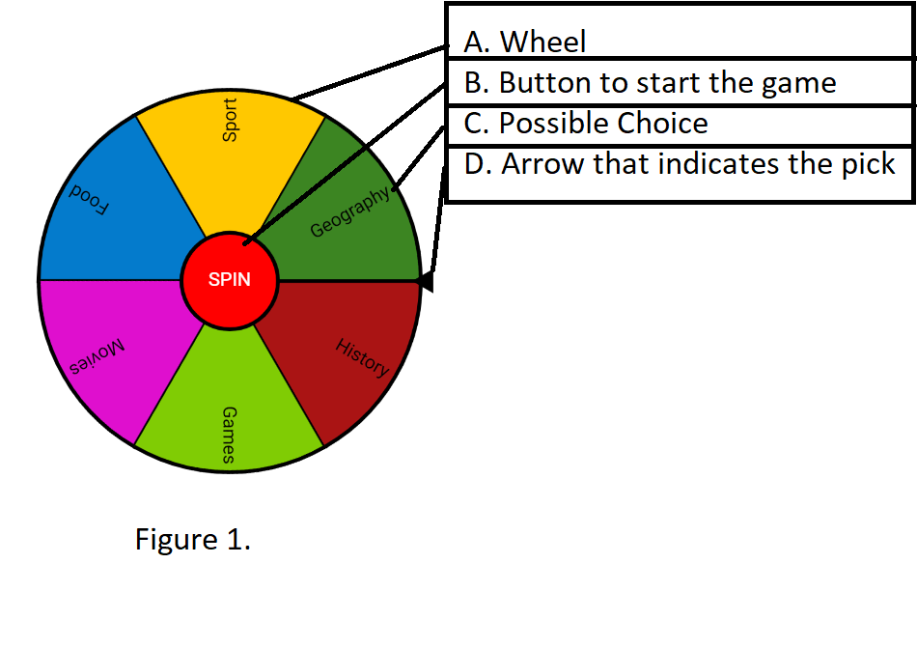

Figure 1.1

Figure 1.2

The player will then start the 1 minute 30 second timer and begin to find pictures that can be associated with that subject without directly be involved with that subject (For example, a toy lightsaber from star wars is acceptable but a picture of Luke Skywalker is not.) For each correct answer the person using the pictures will gain points whilst the guesser will be rewarded with 1 point. However, if the player is deemed to have cheated (This is at the discretion of the other players) then their turn will be cancelled out and that will be deducted a point. The overall aim of the game is to be the first to gain 5 points.

# Gameplay

Figure 1.3, 1.4 and 1.5 (As seen below) is a brief summary of how the game is played.

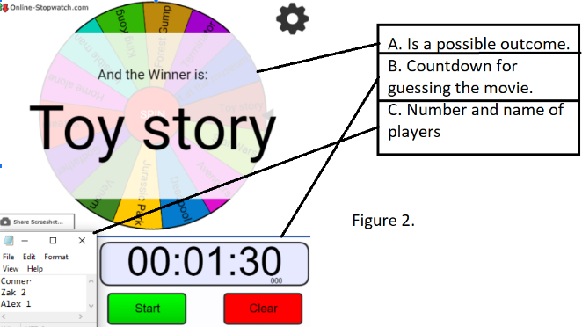

Figure 1.3

This is the movies category and as seen, toy story was the chosen subject.

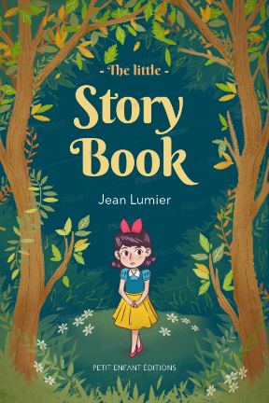

This depicts the process the player would take within the game, first showing a toy, then showing a story, with the end product being toy story.

Figure 1.5

Figure 1.4

Once the player has guessed this particular topic, the play then continues in a clockwise motion till one singular player has reached the point limit and won the game.

# Play testing

Two rounds of playtesting were conducted during this process, the first was internal testing to discover whether the game was ready to be tested by other players. Whilst the game ran smoothly, 1 issue that arose was connectivity issues due to the equipment for the game being located online. With this being a problem out of the user’s control, the project was pushed to external testing with some positive feedback being presented “I like the fact that the games were quick and easy to understand”.

# Teamwork

Creating this project was not as simple as the premise suggests, incorporating many complex mechanics and rules to allow the game to flow smoothly. Therefore, team collaboration was so important to the success of this project, assigning several different creative sections to each member to separate the workload as to manage the time much better. This was reflected in the testing as there was time for 2 separate rounds, rather than the standard 1 round.

# Reflection

Reflecting upon the experience this project gave to me, it has been a huge eye opener as to the importance of time management within a time constricted project. Learning that by separating the workload accordingly between each member of the team, time can be saved and can therefore be spent completing extra tasks the project might require, such as an extra round of playtesting or adjustments to the premise or mechanics of the game.

Members of the team: Zakaria Ahmed, Connor Hadley, Alexandru Zarnescu